COSCARE - H ACID

*(INCI Name: Sodium Hyaluronate)*

# Description:

COSCARE- H ACID is a sodium salt form of Hyaluronic Acid. Hyaluronic Acid is a natural biomolecule widely found in skin and other tissues. It has excellent moisturizing effect and is internationally known the ideal Natural Moisturizing Factor (NMF). It is a substance with good moisturizing properties for cosmetics found in nature.

**INCI Name:** Sodium Hyaluronate

**CAS No. :**9004-61-9 **M.F.:** (C14 H21NO11) n

# Application:

* Moisturizing agent, anti-wrinkle agent, film former, skin conditioner.
* Used in moisturizing products, anti-ageing products, skin soothing and healing products, etc.
* Suitable for lotion gel, essence, emulsion and cream etc.

# Specification:

|  |  |
| --- | --- |
| **Test Items** | **Specifications** |
| Appearance  White or almost white powder or granule | White or almost white powder or granule |
| Molecular weight |  |
| Sodium hyaluronate content | 95.0% |
| Protein |  |
| Loss on drying |  |
| pH |  |
| Staphylococcus Aureus |  |
| Pseudomonas Aeruginosa |  |
| Heavy metal |  |
| Total Bacteria |  |
| Yeast and molds |  |

**Recommended use level:**

0.1 – 1.0 %

# Use Method:

Add in water phase directly.

# Package:

# Storage:

Store in a cool, dry and well-ventilated place and keep away from strong oxidants

# Shelf life:

Two years

# Health and Environmental Information:

To support Customers in their product safety needs, Chemical Brothers has extensive product Stewardship organization and a team of Product Safety and Regulatory Compliance (PS&RC) specialists available in each area.

# Limited Warranty Information-Please Read Carefully:

The information contained herein is offered in good faith and is believed to be accurate. However, conditions and method of use of our products are beyond our control, this information should not be used in substitution for customer’s tests to ensure that Chemical Brothers products are safe, effectives and fully satisfactory for the end use. Suggestions of use shall not be taken as inducements to infringe any patent.

Your exclusive remedy for breach of such warranty is limited to refund of purchase price or replacement of any product shown to be other than as warranted.

Company specially disclaims any other express or implied warranty of fitness for a particular purpose or merchantability.

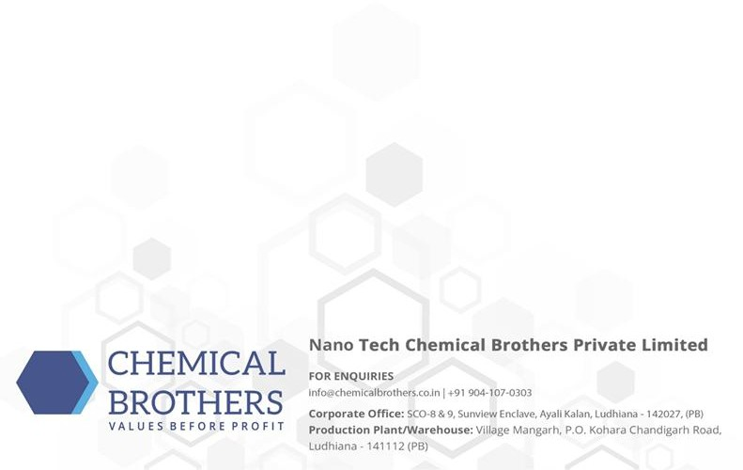

Company disclaims liability for any incidental or consequential damages. For further information please consult to the sales representative.

NB: INCIs may be modified or completed in accordance with updates provided by suppliers, regulations, changes in formula in agreement with client, r on the request of this one.